

OCTOBER CALENDAR

OCTOBER

New Classes: Star Puppy, Introduction to Scent Work

Specials: CGC/CGCA/CGCU testing. Sat 18th-NEW buried practice. Open to everybody $25/2 runs

WEDNESDAY 1

10-11 Novice Scent Work A

11:20-12:30 Intermediate Scent Work A

12:40-1:40 Intermediate Scent Work B

5-6 Novice Trick Dog

**6:10-7:10 STAR PUPPY-Graduation Day**

THURSDAY 2

10-11 Novice Scent Work C

5-6 Family Dog

*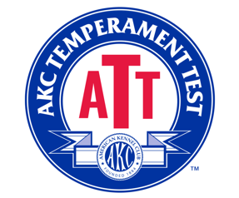SATURDAY 4-SPECIAL*

*AKC TEMPERAMENT TEST*

*SUNDAY 5-SPECIAL*

*AKC FARM DOG*

MONDAY 6

10-11 Novice Scent Work D

5:30-6:30 Advanced Trick Dog-last class

WEDNESDAY 8

10-11 Novice Scent Work A

11:20-12:30 Intermediate Scent Work A

12:40-1:40 Intermediate Scent Work B

5-6 Novice Trick Dog-last class

**THURSDAY 9

10-11 Novice Scent Work C

5:00-6:00 Family Dog

SATURDAY 11

10-11 Excellent Scent Work

Monday 13

10-11 Novice SW D

TUESDAY 14

3-4 NEW STAR PUPPY-*tentative start*

WEDNESDAY 15

10-11 Novice Scent Work A

11:20-12:30 Intermediate Scent Work A

12:40-1:40 Intermediate Scent Work

THURSDAY 16

10-11 Novice SW

3-4 NEW Introduction to Scent Work-*tentative start*

5-6 Family Dog

SATURDAY 18

10-11 Excellent SW

11:30-12:30 Try the new BURIED, 2-runs

Monday 20

10-11 Novice SW D

TUESDAY 21

3-4 STAR Puppy

WEDNESDAY 22

10-11 Novice SW

11:20-12:30 Intermediate Scent Work A

12:40-1:40 Intermediate Scent Work B

THURSDAY 23

10-11 Novice SW (may need to move)

3-4 Introduction to Scent Work

5-6 Family Dog

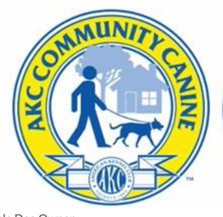

FRIDAY 24-SPECIAL

CGC/CGCA/CGCU Testing-Wilsonville

Email [petslove2play@gmail.com](mailto:petslove2play@gmail.com) to sign up

SATURDAY 25

10-11-Excellent SW

MONDAY 27-**HALLOWEEN DRESS UP WEEK**

10-1 Novice SW D

TUESDAY 21

3-4 STAR Puppy

­­­WEDNESDAY 29

10-11 Novice Scent Work A

11:20-12:30 Intermediate Scent Work A

12:40-1:40 Intermediate Scent Work B

THURSDAY 30

10-11 Novice SW

3-4 Introduction to Scent Work

5-6 Family Dog